Will writing and land ownership education in Kayunga, Uganda
SSA story of change

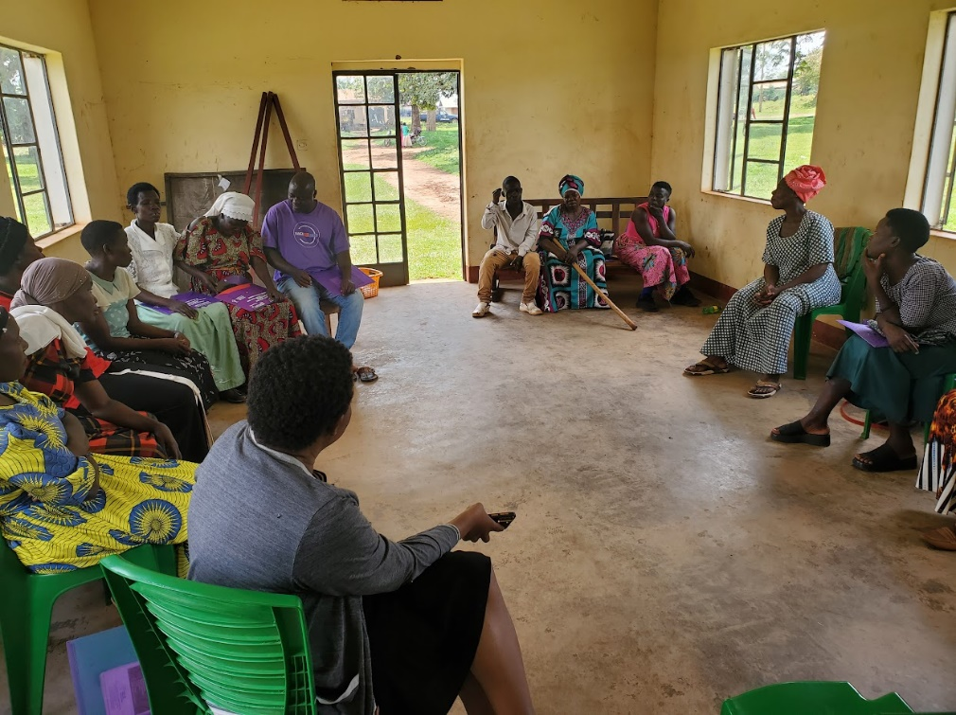

Nassimu Kato (second from right) seated with other Kayunga paralegals

Nassimu Kato is a paralegal from Kayunga Municipality, and a member of the Kirikumuno Kayonjo Women’s Group. When she received paralegal training from SSA in the spring of 2023, she realized that many in her community did not know about wills. In response, Nassimu began leading sensitizations on will writing and land ownership. The response to her trainings has been overwhelmingly positive. Locals in her community have even requested for assistance in writing wills of their own. They have also asked that Nassimu speak with local government officials and other relevant stakeholders such as land NGOs to come and hold mass sensitizations on how to acquire land titles.
Acquiring land titles and writing wills is an important step in achieving equal access to land by formalizing land ownership, thereby decreasing instances of illegal evictions.

