Kamuli Municipality: Protecting the Rights of Children
A case story from paralegal Elizabeth Nabirye
I handled the case of an HIV positive child who had lost both his parents to AIDS. Now in the care of another family, he was being neglected by and mistreated. He was denied an education, fed poorly, and forced onto the streets to beg. As a result of these circumstances, he ran away from the home and sought help from paralegals. I sat down with his guardian to find out why the child was being treated so poorly. She disclosed that as an HIV positive child, she felt caring for him was unnecessary. Thinking he would die either way, she felt there was little point feeding him or sending the young boy to school. I was touched by the story, and as a paralegal used my knowledge on the Ugandan constitution to explain to the family children’s inherent rights and that even if he is HIV positive, he still deserves the same rights as any other child such as right to schooling, adequate nutrition, play (etc.). The woman understood my message and was sensitized to the rights of youth and those with HIV/AIDS. But the case did not end there. The woman told me she was a widow who struggled to provide for her family, let alone this young boy placed in her care. Upon hearing this I referred the family to an organization in the community that cares for at risk youth. With this linkage, they have been able to set the boy up with funding for school fees. With this support, he is now a happier, healthier child that eats well and is able to attend school.
People living with diseases such as HIV are often stigmatized in Ugandan society and are denied their fundamental rights. As a paralegal it is my job to sensitize communities and try to protect the most vulnerable people from harm. With the help of training from SSA and Rooftops Canada, I have been equipped with the knowledge and skills to provide this support.

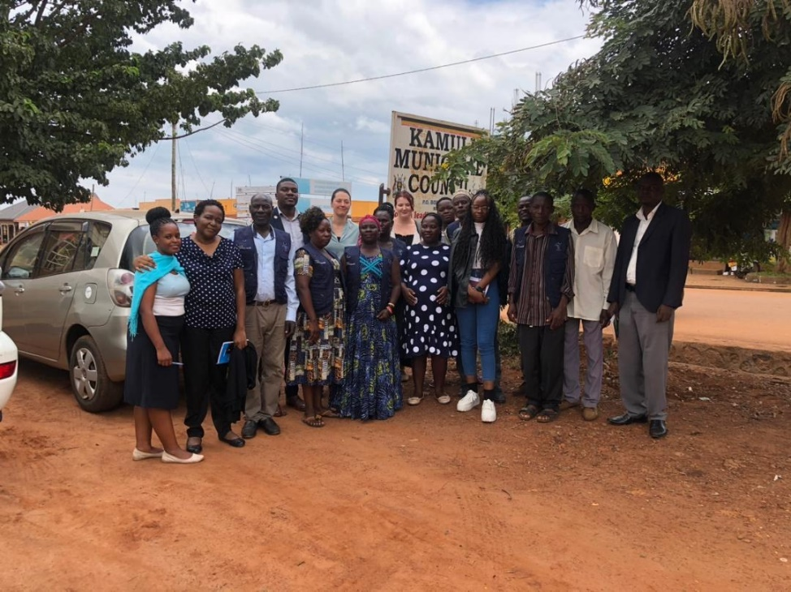
Kamuli Paralegals along with SSA, GAC and Rooftops Canada staff

