In early November a case came to Juliet Nandawula, a Kamuli Municipality paralegal from SSA’s Women’s Spaces Project. The case was of a man dealing with a familial land access issue. After his father died, he had bequeathed land to the son in his will. Unfortunately, the man’s stepmother (wife of his late father) was not allowing him onto the land. Not understanding that her stepson had legal access to the land, she forbade him from using the property.
Upon being presented the case, Juliet coordinated with the local chairman (LC1) to set up a mediation session between the man and his stepmother. Explaining the legally binding nature of her late husband’s will, she ensured the stepmother understood she had to allow her stepson access to the land, as some of it was rightfully his. She explained it is a crime to deny access, and there would be penalties should she refuse to comply. After the mediation, the stepmother realized her mistakes and asked for forgiveness from her stepson, explaining she had not known about the law. The son was able to work through the disagreement and now has full access to his land.
Through The Women’s Spaces Project, paralegals are equipped with the tools and knowledge to support all people in their community facing legal challenges. Although supporting women’s access to land, housing and livelihoods is the utmost priority, it is important to recognize that anyone can face a denial of their rights. SSA, through the work of its community paralegals continue to assist anyone need of support.
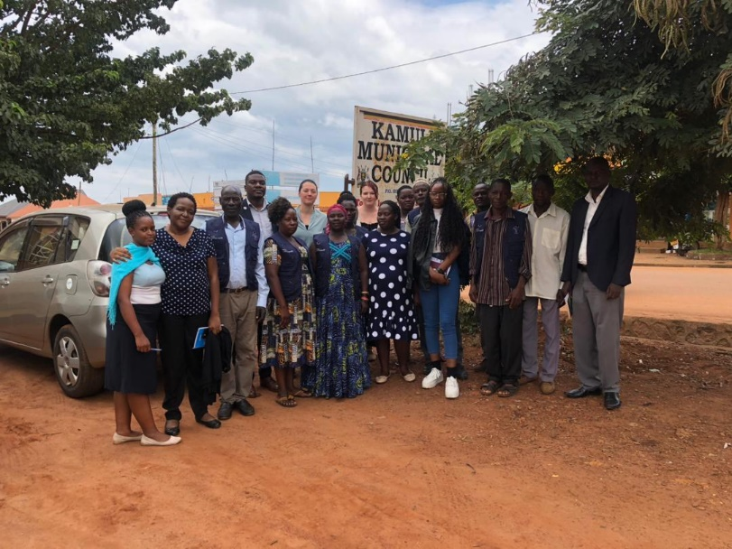

Juliet Nandawula (fourth from left) with other Kamuli paralegals and SSA staff

